TEMPORAL ANALYSIS OF VEGETATION LOSS IN OBUASI USING NORMALIZED DIFFERENCE VEGETATION INDEX DATA FROM 1990 TO 2024
Blessed A. Appiah
Kwame Nkrumah University of Science and Technology, Kumasi

Abstract
This study is a geospatial and temporal analysis of environmental changes, particularly vegetation loss, and its implications for sustainable development and policy planning in Obuasi. It examines vegetation loss in Obuasi, Ghana, over a period of 34 years, from 1990 to 2024, utilizing the Normalized Difference Vegetation Index (NDVI) analyzed from Landsat satellite imagery downloaded from USGS Earth Explorer and preprocessed to ensure consistency and accuracy in the analysis.
The goal of the study is to assess changes in vegetation cover and health and understand the impact of anthropogenic activities and urban expansion on the local ecosystem to inform sustainable land management practices. NDVI serves as a crucial metric for assessing vegetation density and distribution. The research focuses on five key years—1990, 2000, 2010, 2020, and 2024—to analyze spatial and temporal changes in vegetation cover using Geographic Information Systems (GIS) tools. The findings reveal significant variations in vegetation cover, with a noticeable decline in high vegetation areas and an increase in low vegetation zones, indicating substantial environmental degradation. These changes are largely attributed to urban expansion and other human activities like the increase in activities of illegal miners. The pictorial representation of the process of vegetation loss is essential in order to fully appreciate the urgency of land reclamation and afforestation actions and policies. The implications of these findings reveal the urgent need to implement sustainable land management practices to mitigate further vegetation loss and support local environmental conservation efforts. This research contributes to a deeper understanding of land cover dynamics and provides valuable insights for environmental planners and policymakers, aiding in the development of strategies to combat ecological stress and promote conservation in rapidly growing regions.

Keywords: Temporal analysis, vegetation cover, GIS (Geographic Information Systems), NDVI (Normalized Difference Vegetation Index), conservation, natural resource.
Blessed Appiah: Tel.: + 233 55 1082276 ; E-mail address: appiahblessed5@gmail.com

INTRODUCTION

Issues on the rise and fall of vegetation cover and its related implications have been at the top of global discussions. Concerns have been raised regarding environmental protection and climate change. An increase in population, destruction of environmental resources, environmental pollution, and the introduction of various forms of land use planning are among the issues threatening the environment today (Vernon, 2002). There is a declining rate of vegetation cover, which is alarming given its critical role in maintaining ecological balance, supporting biodiversity, and regulating climate.
Africa has been experiencing a significant loss in forest cover, with the highest rate of deforestation among all continents. According to the FAO, Africa lost nearly 4 million hectares of forest annually between 2010 and 2020. This loss is primarily driven by factors such as agricultural expansion, logging, and the demand for charcoal as a primary fuel source. The rapid population growth and the need for land to sustain livelihoods further exacerbate the issue (Earth.org, 2012).
The country's annual deforestation rate was estimated to be 1.3%. Between 1990 and 2005, Ghana lost a quarter of its total forest cover (Boafo, 2013). Various human activities led to a decrease in forest cover from 8.2 million hectares to approximately 0.836 million hectares by 2000, indicating an annual deforestation rate of 2.8% (EPA, 2004). If this rate continues, Ghana's forests could completely disappear within 25 years (Boafo, 2013). Anthropogenic activities and actions are the proximate causes of deforestation and forest degradation (Koranteng & Zawila-Niedzwiecki, 2015). In our area of study, mining (both legal and illegal) is one major cause of the issue of deforestation.

Ghana regained her position as the leading producer of gold in Africa, having overtaken South Africa (Akufo-Addo, 2024). However, this mineral wealth has often failed to translate into substantial benefits for local communities (K. Peprah, 2008). Nowhere is this disparity more evident than in the Ashanti region, notably in Obuasi, where gold mining has historically underpinned local and national economies. Nevertheless, this economic prosperity has exacted a severe environmental toll, marked by deforestation, soil degradation, and pollution, profoundly impacting local vegetation cover.
Mining is not the only cause of the recent loss in vegetation cover in this region. Kofi Korle categorized such factors into climatic, industrial, and anthropogenic categories (Korle, 2020). Unfortunately, leadership and management approaches have not provided the needed remedies to curb this (K. Peprah, 2002).

This study employs QGIS, a powerful Geographic Information System (GIS) tool renowned for its capability to spatially analyze and visualize environmental data. It aims to comprehensively analyze vegetation cover loss in Obuasi from 1990 to 2024. By integrating data from satellite imagery and ground surveys, the research provides a detailed understanding of spatial patterns and trends in vegetation dynamics over this period. Through this analysis, the study seeks to contribute valuable insights into the factors driving vegetation loss in Obuasi, offering a basis for informed environmental policies and sustainable land management practices in the region.

MATERIALS AND METHODS

Study Area

Obuasi is a prominent town situated in the southern part of the Ashanti Region in Ghana. Geographically, it is positioned at approximately 6.1900 degrees north latitude and 1.6500 degrees west longitude. Known primarily for its extensive gold mining operations, Obuasi hosts one of the largest gold mines in Ghana, contributing significantly to both the local and national economy. This area was chosen due to its historical significance in gold mining and the accompanying environmental challenges, particularly concerning vegetation cover loss.

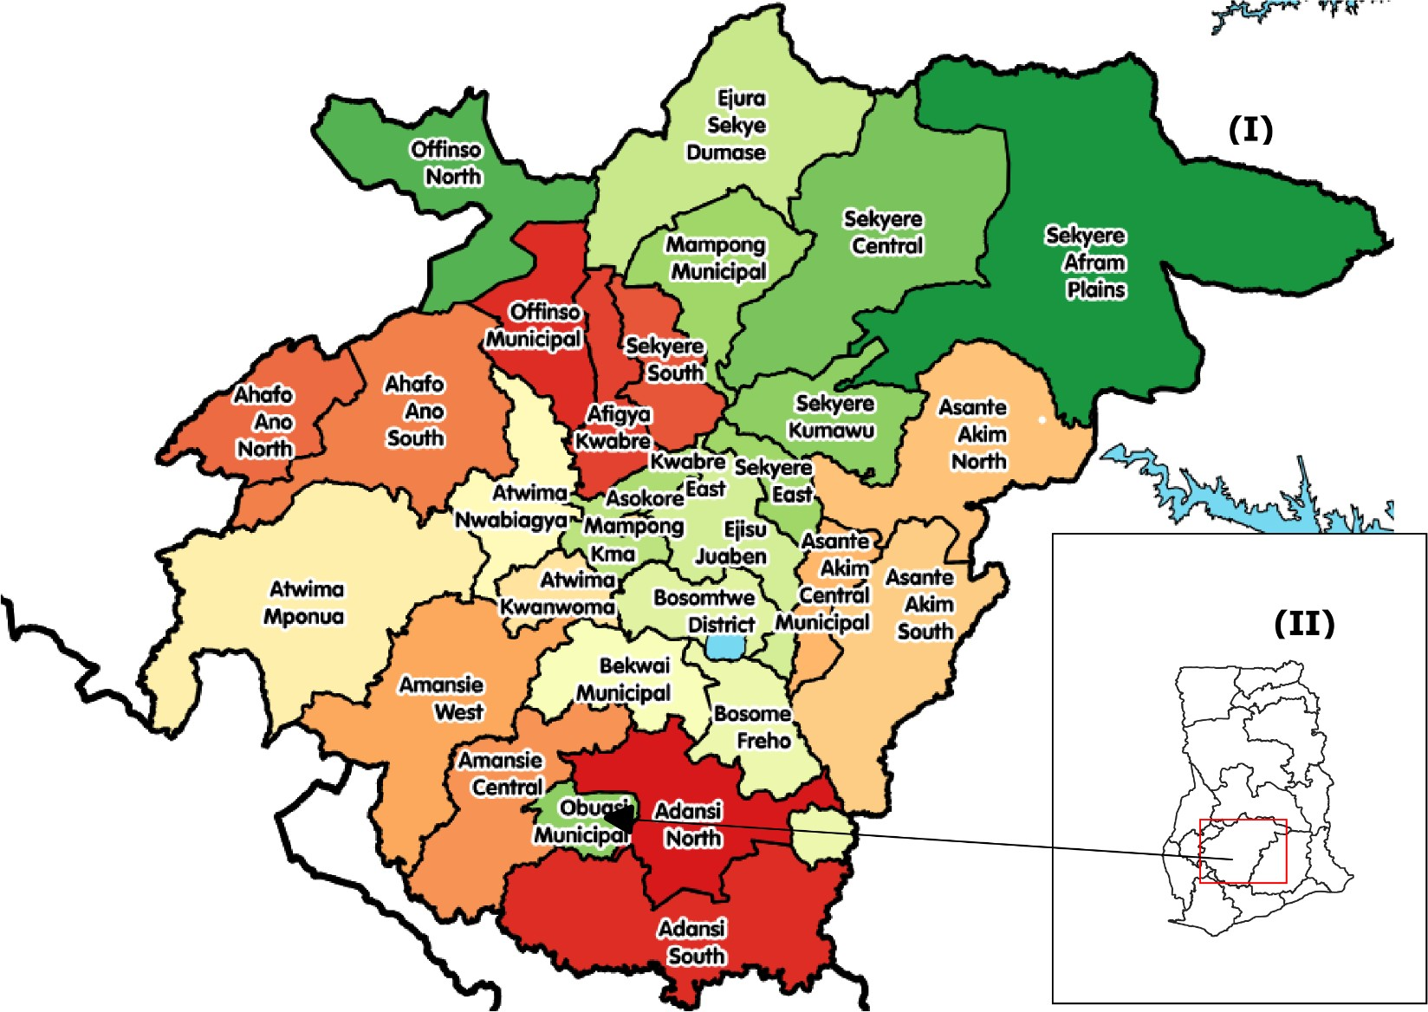

Fig. 1 Map of study area (Source: Wikipedia). Map (I): Ghana and Map (II): administrative districts of Ashanti Region.

Data Collection

Data for this study were obtained from satellite imagery and ground surveys. Satellite data were sourced from the USGS Landsat 7 imagery spanning five key years: 1990, 2000, 2010, 2020, and 2024. Ground surveys complemented satellite-derived information, providing validation and enhancing the accuracy of vegetation cover assessments. The projection used was WGS 84 / UTM zone 30N.

AOI | 1990 | 2000 | 2010 | 2020 | 2024
Obuasi | Landsat 4-5  TM (1990) | Landsat ETM+ (2000) | Landsat ETM+ (2010) C2L2 | Landsat 7  (2020) | Landsat 7  (2024)

Table 1: Satellite data properties

Data Processing

Satellite imagery underwent preprocessing using ENVI (Environment for Visualizing Images). This involved radiometric and atmospheric corrections to standardize data quality across all time periods and ensure consistency in analysis.

NDVI Calculation

The Normalized Difference Vegetation Index (NDVI) was calculated to assess vegetation cover dynamics in Obuasi from 1990 to 2024. Landsat bands 3 (Red) and 4 (Near-Infrared) were utilized for NDVI computation, following the formula: NDVI = (NIR - Red) / (NIR + Red) where NIR (Near-Infrared) and Red represent reflectance values captured by Landsat sensors. This method is used for the quantification of vegetation density and health across the study area,

with higher NDVI values indicating denser vegetation cover and lower values suggesting sparse vegetation or bare soil.

Spatial Analysis

QGIS (Quantum GIS) was instrumental in conducting spatial analysis and visualization. It enabled the assessment of vegetation cover loss trends over the study period, integrating satellite data and ground survey results. This approach facilitated a comprehensive spatial understanding of how vegetation dynamics evolved in Obuasi.

Data Analysis and Representation

Processed data were organized and analyzed using Excel. Excel facilitated statistical analysis and the visualization of vegetation cover loss trends across different temporal intervals and spatial extents. This step was crucial in identifying patterns and trends in vegetation dynamics, providing insights into the drivers of environmental change in the region.

Results

This section presents the results of the NDVI analysis conducted for the years 1990, 2000, 2010, 2020, and 2024 in Obuasi, Ashanti region. The analysis aimed to assess changes in vegetation cover over time, using satellite imagery and the NDVI as a measure of vegetation health. Table 1 shows the maximum, minimum, and mean NDVI values for each year analyzed. The representation of the NDVI values represents the level of vegetation cover in the Obuasi area.

It is imperative to note that in areas like Obuasi, where vegetation cover is typically sparse compared to forests or rural areas, the standard NDVI classification ranges may need adjustments. Urban environments often have a higher proportion of built-up areas and impervious surfaces, which can result in lower NDVI values that do not fit neatly into traditional high vegetation categories. Therefore, while the standard NDVI ranges provide a useful framework, they may not be strictly applicable in urban contexts without some adaptation. Adjusting the classification ranges can help accurately reflect the specific vegetation dynamics and land use patterns characteristic of urban areas like Obuasi.

NDVI values typically range from -1 to 1 and provide crucial information about vegetation health and coverage. Low values (NDVI < 0.1) correspond to areas with sparse vegetation, such as shrubs or grasslands, water bodies or non-vegetated areas like bare soil, rocks, or urban areas. Moderate values (0.1 ≤ NDVI ≤ 0.3) indicate moderate density vegetation, including crops and forests with some canopy gaps. High values (NDVI > 0.3) signify dense and healthy vegetation, such as tropical rainforests or very healthy crops. This study categorized the NDVI values into three sections: low vegetation, medium vegetation, and high vegetation areas. The values derived from the analysis is represented in Table 1 below.

Table 1: NDVI Values from 1990 to 2024

Year | Minimum NDVI | Maximum NDVI | Mean NDVI
1990 | -0.0093842 | 0.524745 | 0.2576804
2000 | -0.339806 | 0.481865 | 0.0710295
2010 | -0.0918367 | 0.385475 | 0.14681915
2020 | -0.145161 | 0.375 | 0.1149195
2024 | -0.222 | 0.384615 | 0.0811965

The maximum NDVI values exhibit a general declining trend from 1990 (0.524745) to 2020 (0.375), with a slight increase in 2024 (0.384615). This decline suggests a reduction in the highest levels of vegetation greenness observed over the years. The minimum NDVI values show significant fluctuations, with the lowest value recorded in 2000 (-0.339806). The minimum values indicate areas with little to no vegetation, due to extensive mining activities and environmental degradation. The mean NDVI values decreased substantially from 1990 (0.2576804) to 2000 (0.0710295), reflecting a significant reduction in average vegetation health. While there was a partial recovery in 2010 (0.14681915), the mean values remained relatively low in subsequent years.

Trend analysis

NDVI Analysis for 1990

Fig. 2 Images for 1990

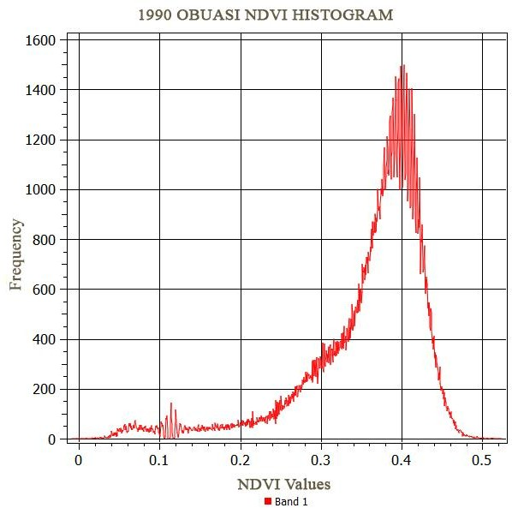
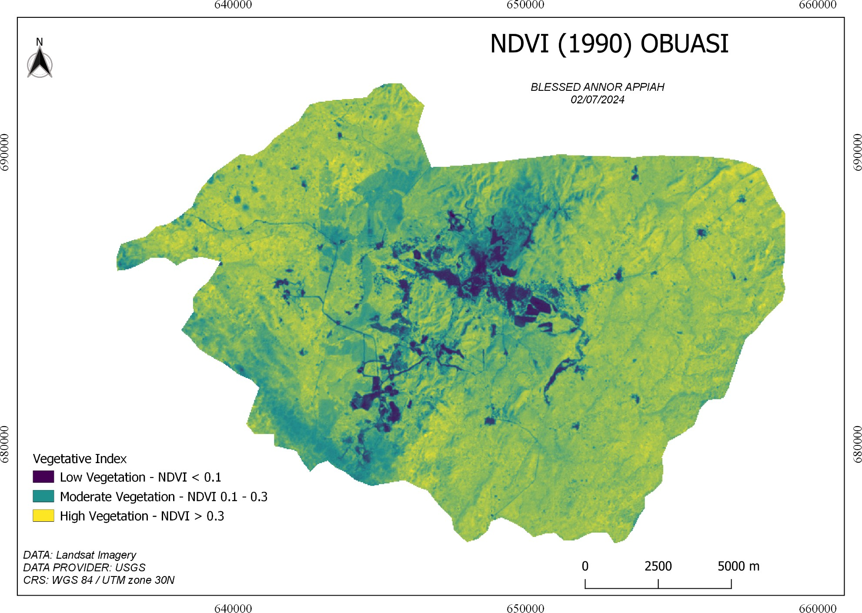
(a) (b)

According to Obuasi's 1990 NDVI analysis, the area is primarily covered in lush vegetation. The histogram shows NDVI values between 0.0 and 0.5, with a notable peak at 0.4, signifying a high density of vegetation. This is supported by the accompanying map, which shows large stretches of high vegetation (NDVI > 0.3), mostly in the central and northern regions. Additionally common is moderate vegetation (NDVI 0.1 to 0.3), as indicated by the map's green regions and the histogram's progressive increase in frequency. As expected from the lower frequencies for these values in the histogram, low vegetation regions (NDVI < 0.1) are sparse and scattered. Obuasi has a robust vegetation cover overall, according to data from 1990, with the bulk of the region falling into the moderate to high vegetation classifications. This suggests a healthy and relatively undisturbed environment during this period.

NDVI Analysis for 2000

Fig. 3 Images for 2000

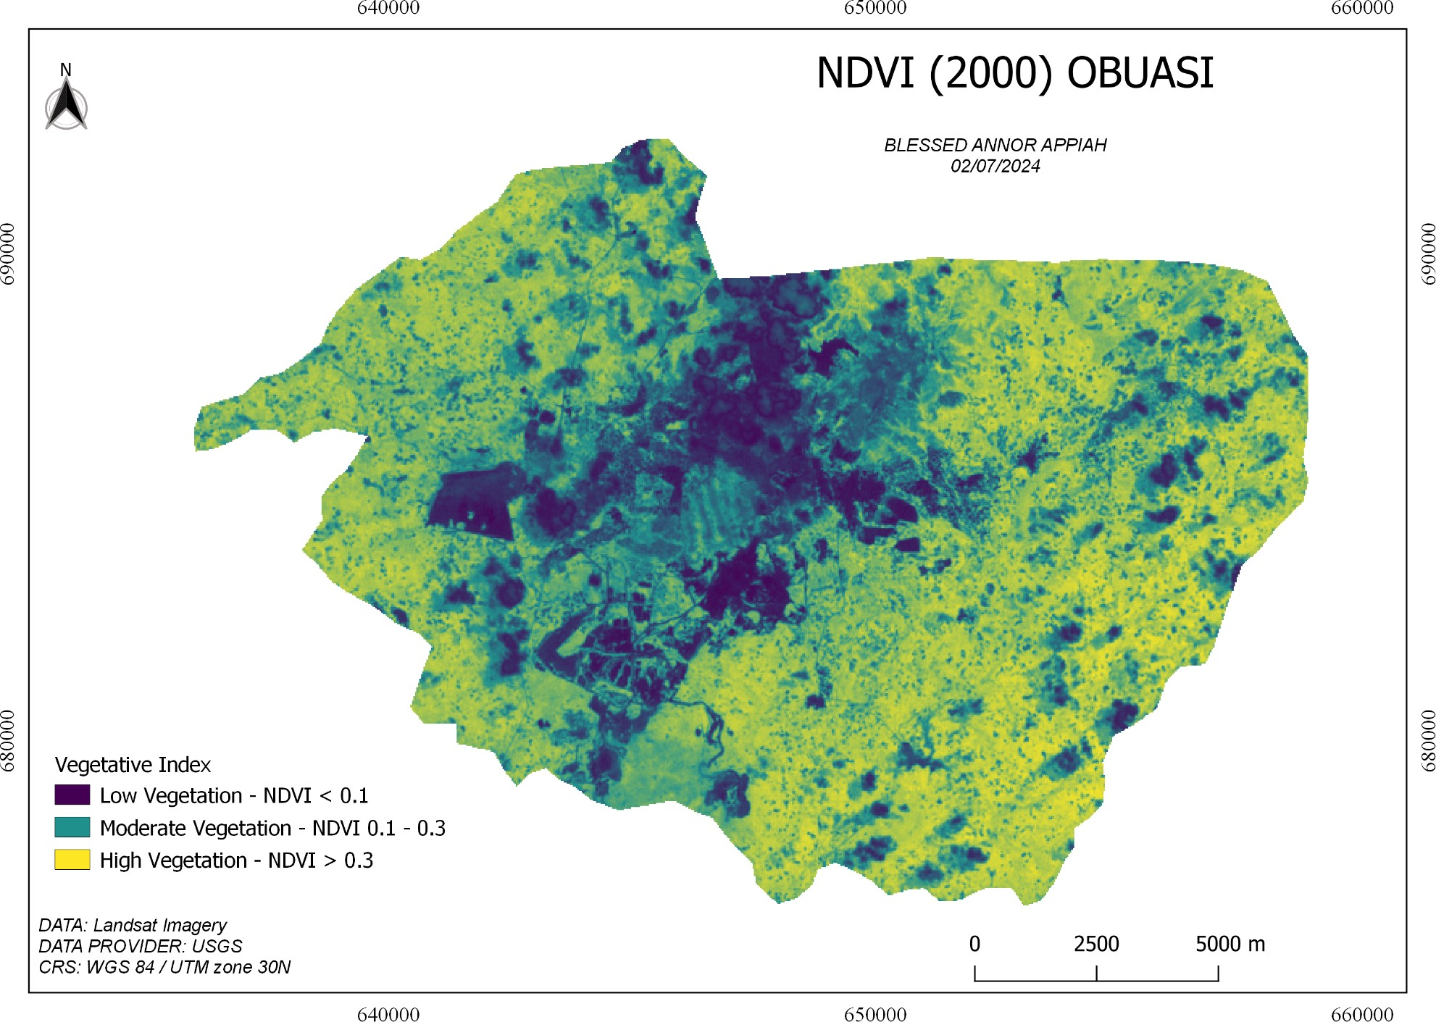
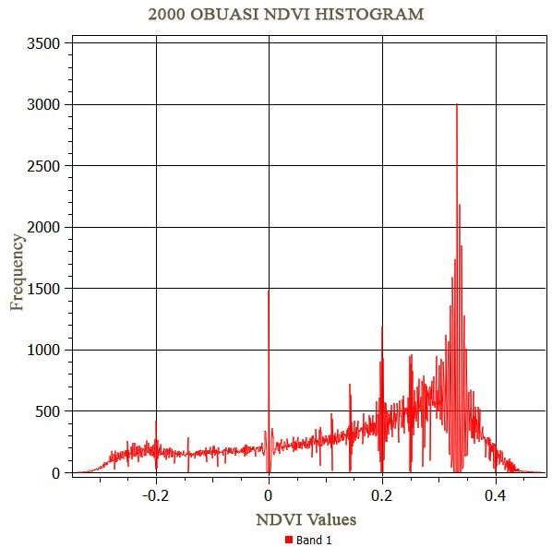(a)
(b)

The NDVI study for Obuasi in 2000 shows significant alterations in the plant cover when compared to 1990. The histogram shows an NDVI value range largely from -0.2 to 0.4, with a noticeable peak at 0.3. This points to a minor movement in the direction of moderate vegetation levels. This distribution is further illustrated by the following map. While they still exist, high vegetation regions (NDVI > 0.3) seem to be less widespread than they were in 1990. The majority of these locations are found in the region's center. As seen by the apex of the histogram, the moderate vegetation regions (NDVI 0.1 to 0.3) are more widely distributed. Particularly in the northern and southern regions, low vegetation areas (NDVI < 0.1) are more noticeable and suggest some degradation or changes in land use. The data point to a rise in areas with moderate to low vegetation cover and a decrease in areas with high vegetation cover. This suggests that anthropogenic or environmental stressors may be harming the health of the vegetation in the area.

NDVI Analysis for 2010

Fig. 4 Images for 2010

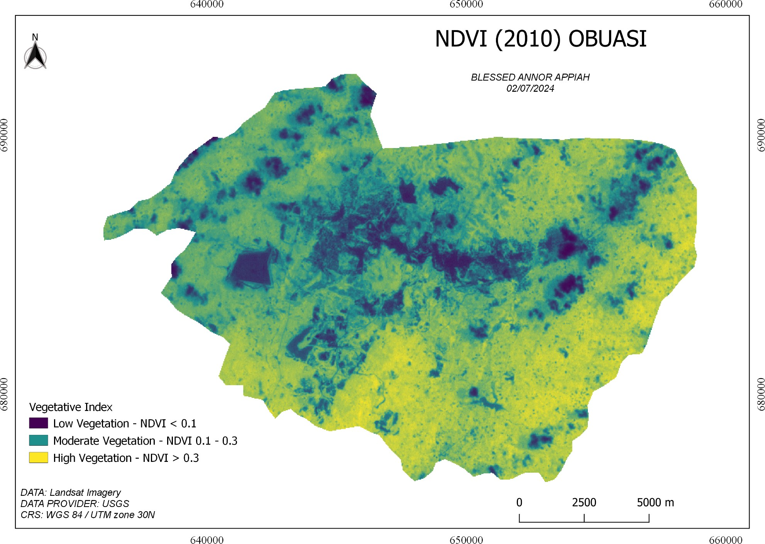
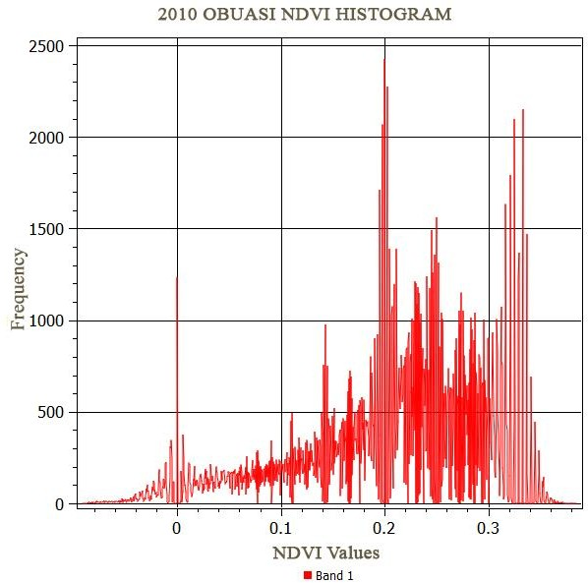
(a)
(b)
The NDVI map for Obuasi in 2010 reveals a varied distribution of vegetation cover across the region, with a significant portion of the area falling within the low to moderate vegetation categories. This is visually represented by the predominance of dark purple and green on the map, indicating sparse to moderate vegetation. The corresponding histogram quantitatively supports these observations, showing a concentration of NDVI values between 0 and 0.3, with pronounced peaks around the 0.2 mark. This indicates that most of Obuasi in 2010 had moderate vegetation cover, as evidenced by the high frequency of pixels in this range. The scattered patches of high vegetation (yellow areas on the map) align with the less frequent NDVI values greater than 0.3 seen on the histogram. Additionally, the presence of values below 0 in the histogram suggests non-vegetated surfaces or water bodies within the region, correlating with dark areas on the map.

NDVI Analysis for 2020

Fig. 5 Images for 2020

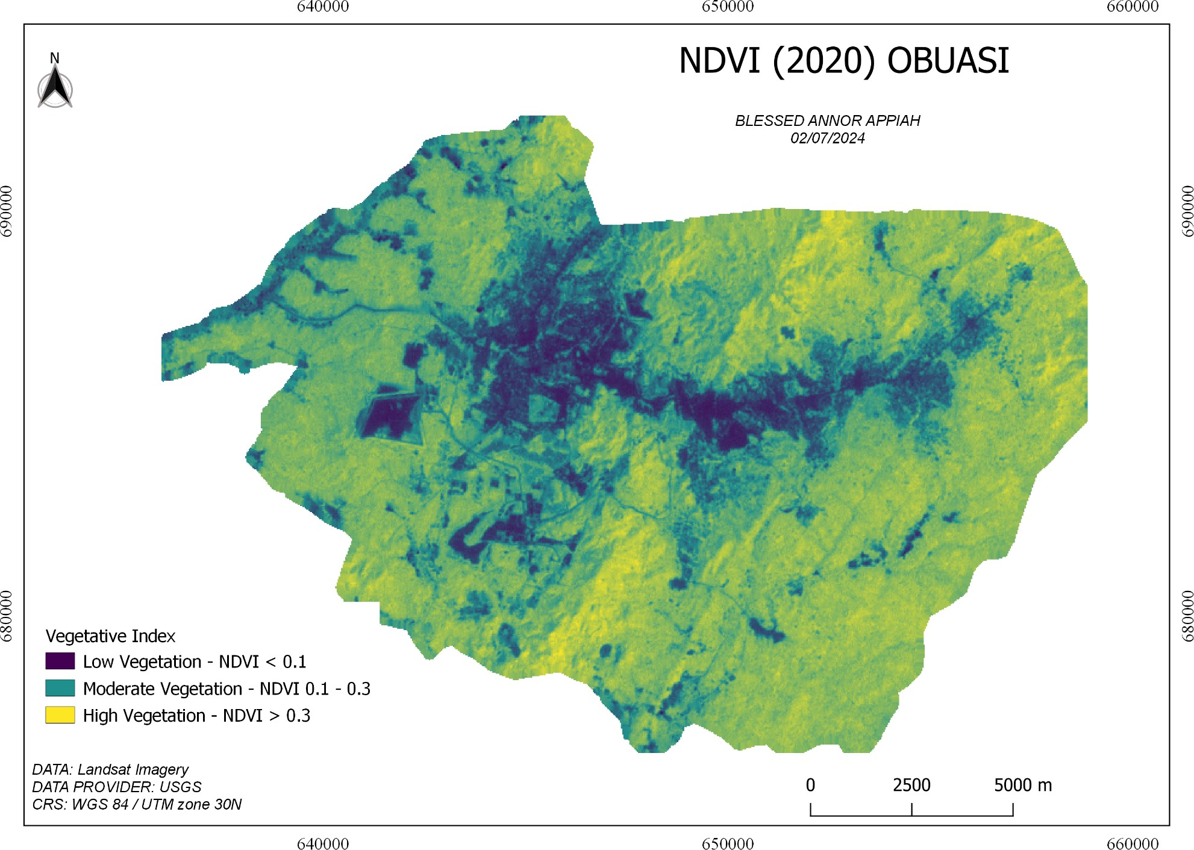
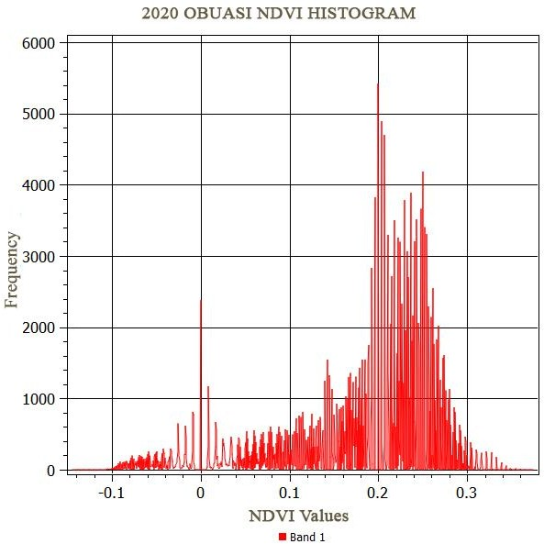
(a) (b)

The 2020 NDVI map and histogram for Obuasi provide important details on the vegetation in the region. The region is predominantly covered with fairly dense vegetation, such as grasslands, crops, and secondary woods, as indicated by the map's extensive green regions, which signify moderate vegetation (0.1 < NDVI ≤ 0.3). These areas also match the noticeable peak in the same range on the histogram. There are fewer places with dense and healthy vegetation, which include mature woods or exceptionally healthy crops, as indicated by the limited yellow areas on the map and the correspondingly lesser frequency in the histogram for high NDVI values (> 0.3). Conversely, the sparse blue areas on the map and the low frequency of pixels in the histogram for low NDVI values (< 0.1) indicate minimal regions with sparse or no vegetation, representing urban areas, bare soil, or water bodies. Overall, the analysis highlights that while moderate vegetation is prevalent, dense vegetation is limited, and sparsely vegetated areas are minimal in Obuasi.

NDVI Analysis for 2024

Fig. 6 Images for 2024

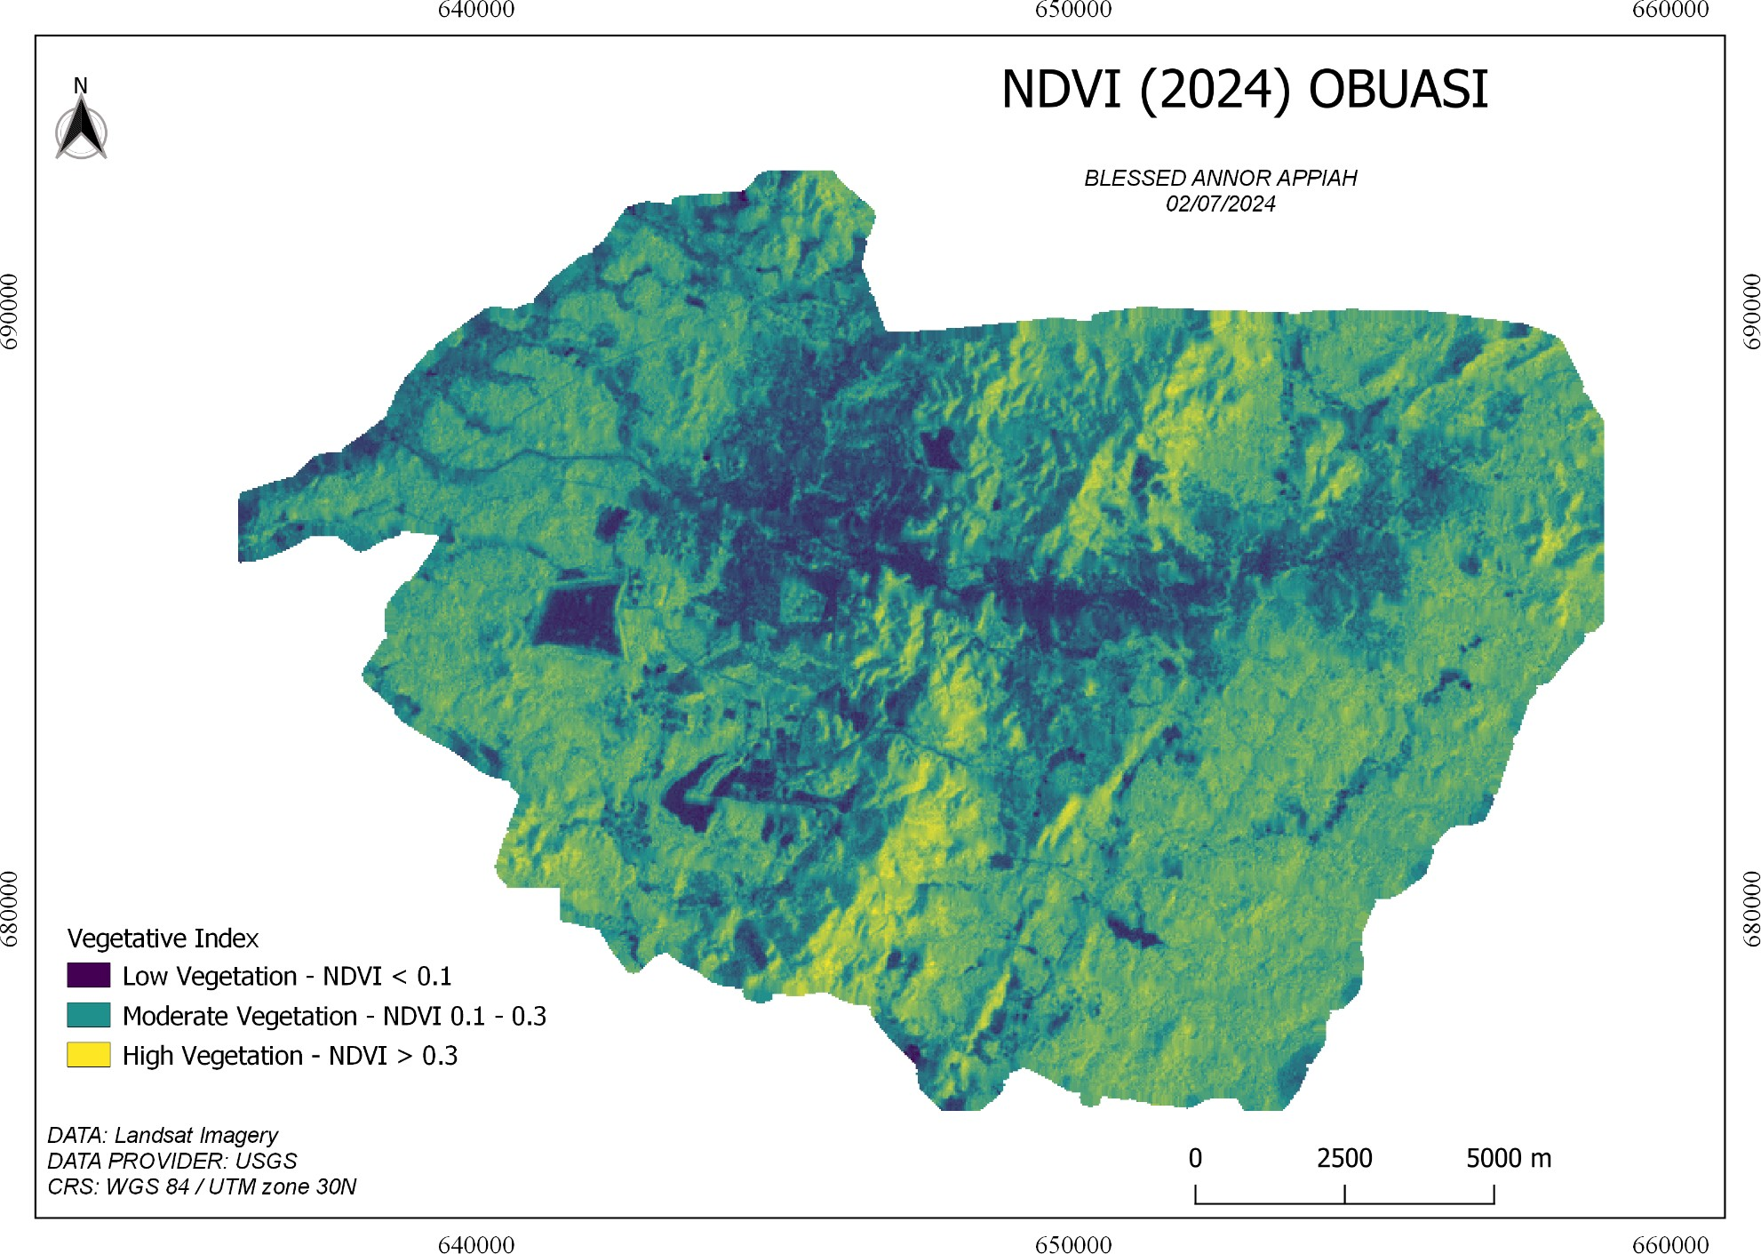
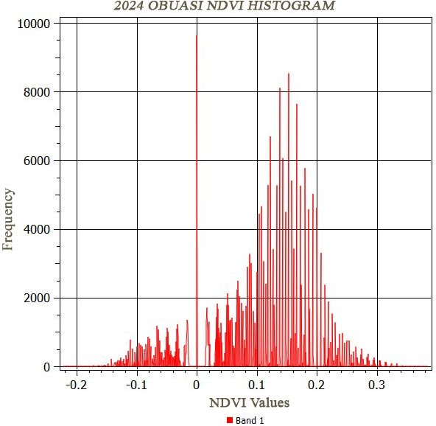
(a) (b)

The NDVI analysis for Obuasi from 1990 to 2024 indicates significant changes in vegetation cover over the decades. The 2024 NDVI map shows areas with low (NDVI < 0.1), moderate (0.1
≤ NDVI ≤ 0.3), and high vegetation (NDVI > 0.3). The accompanying histogram reveals a peak NDVI value around 0.1, indicating a preponderance of moderate vegetation with notable frequencies up to 0.2. When compared to earlier years, a clear trend of decreasing high vegetation areas and increasing low vegetation areas can be observed. The 1990 data showed a more balanced distribution of vegetation, with higher frequencies of dense vegetation, whereas the previous data indicated a shift towards lower NDVI values. This suggests a continuous decline in dense vegetation and an increase in areas with sparse vegetation. The pattern in 2020 continued this trend with an even lower frequency of high NDVI values and a shift towards moderate vegetation. By 2024, the data highlights an ongoing degradation of dense vegetation areas, affirming a long-term decline in vegetation health in Obuasi, likely due to urbanization and other anthropogenic activities.

Discussion

The NDVI analysis for Obuasi from 1990 to 2024 indicates significant changes in vegetation cover, with a noticeable decline in vegetation health over the decades. Initially, in 1990, Obuasi was characterized by robust and dense vegetation. However, by 2000, there were clear signs of degradation, with a shift from high-density vegetation to more moderate and low-density vegetation areas. This trend continued through 2010, 2020, and 2024, revealing a persistent decline in dense vegetation and an increase in sparsely vegetated areas.

Several key findings stand out from this analysis. Firstly, the central and northern regions, which initially had high vegetation density, showed significant reduction over time. By 2024, these areas exhibited a marked decrease in high-density vegetation, highlighting ongoing environmental degradation. Secondly, the increase in low vegetation areas, particularly noticeable from 2000 onwards, suggests substantial land-use changes and environmental stressors impacting vegetation health.

The primary causes of this vegetation decline can be attributed to urbanization, agricultural expansion, and especially mining activities. Obuasi, known for its gold mines, has seen a significant impact from both legal and illegal mining activities. Under Ghanaian law, small-scale gold mining is reserved for Ghanaians. However, the boom in gold prices in the 2000s and Ghana’s unprotected gold wealth drew thousands of Chinese miners to Ghana, who started mining for gold illegally (Crawford et al., 2015). The scale of illegal mining expanded greatly in the 2000s, attracting many foreign miners from neighboring Burkina Faso, Cote d’Ivoire, and countries such as Russia, Armenia, and China. Before 2013, the Ghanaian government largely overlooked the influx of Chinese migrants into the small-scale mining sector. Despite the passage

of the Minerals and Mining Act in 2006, the law was weakened by corrupt officials accepting bribes from Chinese miners, enabling them to continue their activities. (Addy & Adhikari, 2021).

These illegal mining activities, known locally as "galamsey," have had a profound impact on the region's vegetation. The clearing of land for mining operations, along with the pollution and soil degradation resulting from these activities, has contributed significantly to the observed decline in vegetation health. Furthermore, urban expansion and agricultural practices have also played roles in this environmental degradation, as forested areas are converted to cropland or urban settlements. The analysis highlights a continuous decline in vegetation health in Obuasi from 1990 to 2024. The findings emphasize the significant impact of anthropogenic activities, particularly illegal mining, on the region’s vegetation cover.

Conclusion and Recommendations

The NDVI analysis for Obuasi from 1990 to 2024 indicates a significant decrease in vegetation health over the decades. Initially, the region boasted dense and robust vegetation cover, but over time, there has been a marked shift towards moderate and low-density vegetation areas. This decline can be attributed to several factors, including urbanization, agricultural expansion, and most notably, illegal mining activities, known locally as "galamsey." Despite the introduction of the Minerals and Mining Act in 2006, weak enforcement and corruption allowed these activities to continue unabated (Crawford et al., 2015; Botchwey & Crawford, 2019; Addy & Adhikari, 2021).

To address these issues and promote ecological sustainability in Obuasi, several actions are recommended. Firstly, strengthening the enforcement of existing mining laws and cracking down on corruption within regulatory bodies is crucial. Secondly, reforestation programs should be

implemented to rehabilitate degraded lands and restore the region's vegetation cover. Thirdly, promoting sustainable land use practices and providing alternative livelihoods for local communities can reduce the pressure on natural resources. Finally, increasing public awareness about the environmental impacts of illegal mining and engaging local communities in conservation efforts can foster a culture of environmental stewardship. It is possible to halt and eventually reverse the decline in vegetation health, ensuring a sustainable future for Obuasi's ecosystem.

REFERENCES

- Addy, F. D., & Adhikari, S. (2021, February). Galamsey in Ghana: Mitigating its negative effects. *Women in International Security (WIIS) Policy Brief*.
- Akufo-Addo. (2024). SONA2024: Ghana now Africa’s #1 producer of gold. Retrieved from
https://3news.com/featured/sona2024-ghana-now-africas-1-producer-of-gold-akufo-addo/

- Amoah, A., & Korle, K. (2020). Forest depletion in Ghana: The empirical evidence and associated driver intensities. *Forestry Economics Review*.
- Boafo, J. (2013, January 16). The impact of deforestation on forest livelihoods in Ghana.

*Africa Portal*. Retrieved September 12, 2014, from http://www.africaportal.org/articles/2013/01/16/impact-deforestationforest-livelihoods-gh ana#chapter%3C?php print $chapter;?%3E
- 2. Gordon Crawford et al., “The Impact of Chinese Involvement in Small-Scale Gold Mining in Ghana,” E-33110-GHA-1 (International Growth Center, May 2015); Gabriel Botchwey and Gordon Crawford, “Lifting the Lid on Ghana’s Illegal Small-Scale Mining Problem,” The Conversation (September 25, 2019).
- Crawford, G., & Botchwey, G. (2019, September 25). Lifting the lid on Ghana’s illegal small-scale mining problem. *The Conversation*. Retrieved from https://theconversation.com/lifting-the-lid-on-ghanas-illegal-small-scale-mining-problem
-12325

- EPA-Environmental Protection Agency. (2004). Ghana state of the environment report.

EPA Ghana, Accra, 11–51.

- Food and Agriculture Organization (FAO). (2023). *FRA 2025 reporting started in Africa*. Retrieved from
https://www.fao.org/forest-resources-assessment/fra-2025-reporting-started-in-africa/en/

- Koranteng, A., & Zawila-Niedzwiecki, T. (2015). Modeling forest loss and other land use change dynamics in the Ashanti Region of Ghana. *Folia Forestalia Polonica, Series A, 57*(2), 97. https://doi.org/10.1515/ffp-2015-0010
- Peprah, K. K. (n.d.). Impact of mining activities on deforestation in the mining communities of Ghana: The case of Obuasi (Doctoral dissertation). KNUST.
- Rosen, J. (2021). Deforestation in Africa. *Earth.org*. Retrieved from https://earth.org/deforestation-in-africa/

